**Introduction and Objectives:**

A college is a place where you gain most of your knowledge, skills and experience, but deciding which college to attend and what major to study makes it even more difficult. If one wants to earn good money after graduation and wants a satisfactory salary growth after spending years in a particular field, choice of college is a very significant decision. A decision which will influence your future earning potential. The point here is not to make a student choose only that college or major, by which he or she can make lots of money; but to help him or her choosing that college, by which he or she can sound financially good. In this paper, we will examine three prominent elements which will help us determine a good college having a high ROI or equivalent of saying a college that pays you back.

Firstly, salary increase by type of college one attends. It is a fact that your starting salary is affected, depending on which college you attend. For example, a State college, Party college, Liberal Arts college or an Ivy league school. We will explore the starting and mid-career salaries of graduates from an extensive diversity of schools.

Secondly, salaries in particular region. According to the PayScale Inc. survey, graduates from the school in Northeast and California got high salaries in comparison to graduates from Midwest. We will analyze how different region affect the starting and mid-career growth in salaries of graduates.

Thirdly, salary increase by major. One's earning potential is very influenced by major. Most of the degrees can’t pay you back sufficiently, in today's job market a major has a significant influence on well-paying jobs.

**Data:**

All the data is publicly available on Kaggle and Payscale website. In total there are three files, having few common variables like median salary, 10th, 25th, 50th, 75th and 90th percentile. Each row represents the starting and mid-career salaries in the different percentiles. Each column with percentiles represents the growth of salaries over time. Apart from the percentile column, there is the percentage change column which describes the % change in starting to mid-career salary. Salaries by degree dataset have total 50 rows and 8 variables. Every observation in college dataset depicts college name and type of college with its graduates starting and mid-career salaries. Few values are missing in some rows; this would be interesting to analyze how they will affect the findings. The third dataset gives the information of graduates from particular college who belongs to a certain region. There are 320 observations and 8 variables having the name of the college and region in which college exists. Some of the observations have multiple college type, for example a college could be a state college as well as a party college. Few of the colleges have only two percentile values like 75th and 90th, by this data we can only come to a range of higher salaries. But, it might not affect the overall analysis because of the large dataset.

Analysis and Methodology

The analysis will be divided into three part majorly. Firstly, we'll analyse how salaries of different major vary from their starting median salary to mid-career salaries. Secondly, how salaries vary depending on the type of college. Thirdly, how salary differs depending on the region you graduated from and where your college exists.

Let's see the distribution of starting median salary and mid-career salaries of majors.



It is visible that the starting median salary distribution is concentrated within the salary range of $34,000 to $74,300 with a mean of $44,310, and somewhat rightly skewed. Salaries are normally distributed, see Appendix A for the goodness of fit test. Although the salaries of graduates in mid-career are widely spread having the salary range of $52,000 to $107,000 with a mean of $74786. Salaries are normally distributed but are marginally significant, see the goodness of fit test in Appendix A. It seems obvious that the graduates who recently graduated, having no prior experience have less salary than graduates, who are in their mid-career. But, there is a starting salary which is way up in comparison to other graduates, this salary can be seen in the distribution as a dot on the top right corner as an outlier.

Let's check the top salaried major and the percentage change from starting salary to mid-career salaries through the below diagram.



The left side of the black dash line represents the starting salary and another side shows the mid-career salary of a particular major and it also signifies the percentage change from starting to mid-career salary. So, Chemical engineering has the highest median salary of $107,000 with a 69.3% change from a median starting salary of $63,200. 8 out of 10 degrees on top are from Engineering field including the Computer Science. Math, Economics and Physics have high mid-career salary with large percentage change, which signifies a high growth in mid-career whereas physician assistant and nursing have relatively very low mid-career salary growth. See references for detail. Though Philosophy and International relations have a high percentage change from starting to mid-career salaries but due to the fact that they have relatively low starting salary they are not in the top.



Once again 8 out of 15 high salaries belong to Engineering field and some STEM courses including Economics. And, there are very least majors except for them, who are touching six-digit salary figure. So, this majors represents high salary growth potential in mid-career.

It is very interesting that mid-career salaries are so correlated from 10th to 90th percentile. They follow a linear pattern of progression for most majors. It would be interesting to see how mid-career salaries are related to starting salaries.

Salaries of graduates are highly correlated with mid-career salaries with Pearson's r value around 0.85. See Appendix A for the joint plot and prediction plot. Starting mid-career salary has significant p-value as well as the prediction plot has a high R-squared value of 0.72 which means starting salaries can explain about 72% of the variability in the linear model. So, if we want to predict mid-career salary of any major, we can predict it through this model.

The high correlation between the starting salary and mid-career salary indicates that salaries of one or more major have a comparable percent growth. Then this majors can be clustered together to know, which of them end up as high, medium or low mid-career salary brackets.

Please see Appendix A for dendrogram, biplot and cluster means. After running PCA over the 10th to 90th percentile mid-career salary. It is clear that majors can be clustered in 4 groups broadly as interpret by eigenvalues in scree plot. Each of the cluster has significant Chi-sq value in Bartlett's test. The dendrogram and biplot also reflect the 4 cluster which has the different mean salary in each mid-career percentile, can be seen in the cluster means. Clusters in descending order of their salaries are as follows:

1. The Engineering and STEM courses.

2. Finance, Math and Economics

3. A hybrid group including Film, Geography, Techno-business and many more.

4. Education, language and Art

**Analyzing salaries depending on the college type.**



It is clear that both Engineering and Ivy-league colleges have high starting and mid-career salaries. But, Ivy league pulls up in the mid-career salary range. Liberal Arts, Party and State schools graduates have a pretty same mean starting salary range. But, Liberal Arts graduates improve their salaries in mid-career. After performing the ANOVA on both starting and mid-career salaries, O'Brien test gives a significant value for both test i.e. we'll reject the null hypothesis and can say there is variance in the salaries of one or more type of college. After running Tukey's test on starting salaries, Engineering and Ivy-league(A) fall in the same bracket with a p-value of 0.94 and Liberal Arts, Party and State schools(B) in one. See Connecting Letter report and Ordered difference report in Appendix B.

After running Tukey's test on mid-career salaries it is seen that Engineering and Ivy-league graduate’s salary no more fall in the same bracket, salaries of Ivy-league graduates get increased in their mid-career. Liberal Arts and State school graduates mid-career salaries fall in different brackets with party school in both brackets. Though it is clear that comparatively Liberal Arts and Party college graduates have high similarities in their mid-career salaries with a p-value of 0.47. See Connecting Letter report and Ordered difference report in Appendix B.



5 out of 8 Ivy-League colleges are in top 15 with top Engineering colleges like MIT, CalTech and Harvey Mudd. It seems that college does matter in high salaries. Apart from this, there is also a Liberal Arts college in top 15, Bucknell University with graduates having a six-figure salary in Mid-career. While the University of California, Berkeley which is a state university remains in bottom 5 of top 15. Dartmouth tops in Ivy-league, MIT in Engineering, UC Berkeley in State, Bucknell University in Liberal Arts and UIUC in Party colleges.

Some of the schools in the dataset have a dual college type. For example, UIUC is both state and party school, while Randolph-Macon College is both Liberal Arts and Party. From the following visualization, we can interpret that schools which are a state, as well as a party, have higher graduate salary than the schools which are state and non-party. Clearly, having a state-party school acquires graduates a higher starting and mid-career salary.



After running a regression model for predicting the Mid-career salary by starting salary. It is clear that except Ivy-league all other school type has significant p-value, which means starting salaries of graduates from this schools are correlated with their Mid-career salaries. Engineering graduates have the highest R-square value of 0.87. While, State, Liberal Arts and Party schools have R-square value 0.76, 0.72 and 0.67 respectively. Possibly due to the fact that, there are only 8 Ivy-league colleges, and starting salaries of graduates varies from there Mid-career salaries, and it's also possible that graduates from Ivy-League are much lesser than the other schools likely gave us a high p-value. See Appendix B for detailed analysis.



**Analyzing Salaries by region.**

 

Northeastern Region has the highest starting and mid-career salaries, followed by Southern, Midwestern, Western and California respectively. Another reason for Northeastern being the highest salary region is, it has NY, MA and PA states in it, and all the Ivy-League colleges are in Northwestern Region. Apart from the Ivy-League colleges top Engineering Colleges like MIT, PUNY and CMU are in this region. It is interesting that California itself is a region, no doubt the state has many distinguished Universities and Companies. Institutes like Stanford, CalTech, UC Berkeley and Tech giants like Google, Apple and many more are in the region, this contributes to higher salary range and packages.

Let's see how starting and mid-career salaries of the graduates in different regions vary.



Starting salaries of the Northwestern region and California are comparatively high then the other region. The Southern and Western region is somewhat same, led by the Midwestern region.

The median salaries of Northeastern and California are widely spread. It could be possible because of graduates from Ivy-League and Engineering college have a high salary in comparison to other graduates, it causes a wide distribution of salary ranges.

After running ANOVA on each regions starting salaries, O'Brien Test gives a significant value, which means one or more regions have not similar salaries. We already know that Northwestern and California have higher starting salaries, after seeing above visualizations. Though we'll run Tukey's test to see, connecting letter report and Ordered Difference report. It is explicit that, California and Northwestern(A) are at the same level and other three regions are at the same level in starting salaries of graduates. It is worth noting that, Southern and Midwestern have a high p-value of 0.99, so as the Western and Midwestern region. And, the Southern and Western region has a p-value of 1, this shows that salaries of graduates in this regions are slightly similar. See Appendix C for detailed Analysis.

Applying ANOVA on the mid-career salary of graduates by region gave O'Brien test a reasonably high p-value then 0.05. This means we fail to reject the null hypothesis and assumption of ANOVA here remains intact. Mid-career salaries in regions have less variance in it and are kind of similar to each other. Other robust tests like Brown-Forsythe and Levene also gives marginal significant values, signifying that there are fewer variances in the salaries of graduates in all region during their mid-career. Connecting Letter shows the same result as the starting salaries. But, the similarities in mid-career salaries differ a little now, Western and Midwestern have a high p-value of 1, which means salaries of graduates in this both region are pretty much same. See Appendix C for detailed analysis.

**Analyzing Region and type of schools.**



The Midwestern and Southern region has 50 state colleges including UIUC, U Minnesota and Texas A&M, U Texas, Clemson respectively. Party colleges are less throughout the US and Northeastern region has most Liberal Arts college. While California being top in schools and salaries have mostly state schools including UC Berkeley. California has fewer another type of schools. It might be possible because of their policies to give low-cost education to residents. California state colleges have relatively very low intuition fees than the out-tuition fees, which is almost double. Northwestern has most engineering college including MIT. It would be really interesting if we would have the data of Salaries of majors in all region. By that, data we can figure out which region has a high salary for a particular major. For example, Computer Science and Engineering salaries are high in California due to Silicon Valley, but this is just an assumption. A concrete data might help us in finding such things.

Salaries of all type of schools in each region.



State school graduates in California have a higher salary than the state school graduates of another region. Engineering Colleges in California and Northwestern have a neck to neck salaries in mid-career and somewhat similar in the start. Party college have the almost similar salary range in starting and mid-career throughout the US. While Ivy-League being in only one region has higher starting and mid-career salary than all school types in every region.

**Conclusion and key interpretation from all three objectives.**

Key interpretation of the salaries by majors are:

Choose STEM courses, if you want to have a good headstart and smooth mid-career. STEM also have high ROI in less time, see the reference for more detail.

1. New graduates earn around $44k a year, with some having the salary around $74k.

2. Potential high salary and growth are in STEM majors specifically in Engineering. And, in Economics too one can make up to $165k to $200k a year in high mid-career.

3. Starting salaries of few major are low but they have high mid-career growth, like Math, Physics and Economics with average percentage growth of about 96% approx.

4. Most of the time starting salaries determine, how much you can earn in mid-career. A high starting salary might give a high mid-career salary. But it is not true in some cases like in Philosophy and International relations which have percentage growth of about 103% but end up with relatively low-income comparatively.

Key interpretation of the salaries by college type are:

The name does matter, a graduate from Ivy-League mostly have higher starting salaries than graduate from Party or State Schools.

1. Ivy-league and Engineering colleges have high starting salary but Ivy-league graduates earn more than Engineering graduates in Mid-career.

2. Starting salaries of Liberal Arts, Party and State schools are moderately alike. But, Liberal Art graduates earn slightly more in mid-career in comparison to both.

3. Most of the colleges are State School but State-Party school graduates have a higher starting and mid-career salary in comparison to State non-party colleges.

Key interpretation of salaries in different regions are:

California and Northeastern have the highest earning graduates.

1. Engineering college graduates have higher earnings in the Northeastern region as well as in California. Opting Engineering in the Northeastern region might help you fetch high starting and continuous mid-career growth.

2. Choose Northeaster region, if you want to study in a Liberal Arts college.

3. The state schools in California are good and graduates have relatively higher salaries than any state graduates throughout the US.

**References:**

[**http://www.businessinsider.com/stem-majors-earn-a-lot-more-money-after-graduation-2014-7**](http://www.businessinsider.com/stem-majors-earn-a-lot-more-money-after-graduation-2014-7)

[**http://www.ppic.org/publication/higher-education-in-california-student-costs/**](http://www.ppic.org/publication/higher-education-in-california-student-costs/)

[**https://www.payscale.com/college-salary-report**](https://www.payscale.com/college-salary-report)

[**https://www.kaggle.com/wsj/college-salaries**](https://www.kaggle.com/wsj/college-salaries)

[**https://www.forbes.com/sites/brucejapsen/2016/01/29/physician-assistant-pay-reaches-100k-annually/ - 56dc8e8151c6**](https://www.forbes.com/sites/brucejapsen/2016/01/29/physician-assistant-pay-reaches-100k-annually/#56dc8e8151c6)

**APPENDICES**

**Appendix A – Output of Salaries by Majors analysis.**

Fit test of starting median salaries and mid-career salaries respectively.



Summary Statistics of median salaries and mid-career salaries respectively.

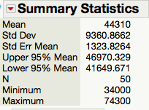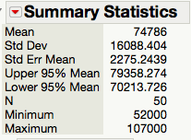

Regression model of starting salaries and mid-career salaries of graduates.

 

Join Plot between the starting salaries and mid-career salaries.

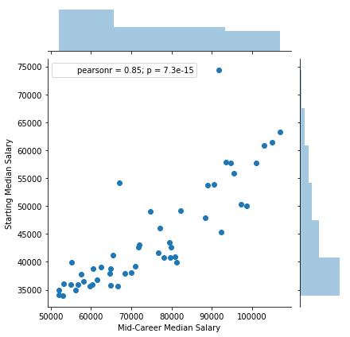

Cluster Analysis:

 

 

Tableau link of the dashboard – <https://public.tableau.com/views/Salaryanalysisofdifferentundergraduatemajors/Dashboard1?:embed=y&:display_count=yes>

**APPENDICES**

**Appendix B – Output of Salaries by College type analysis.**

ANOVA results of Starting Salaries



 

ANOVA results of Mid-Career Salaries

 

 

Tableau Link of the dashboard - <https://public.tableau.com/views/AnalysisofSalariesbyCollegeType/AnalysisofSalarybyCollegeType?:embed=y&:display_count=yes&publish=yes>

Regression model for predicting mid-career salary by type of college

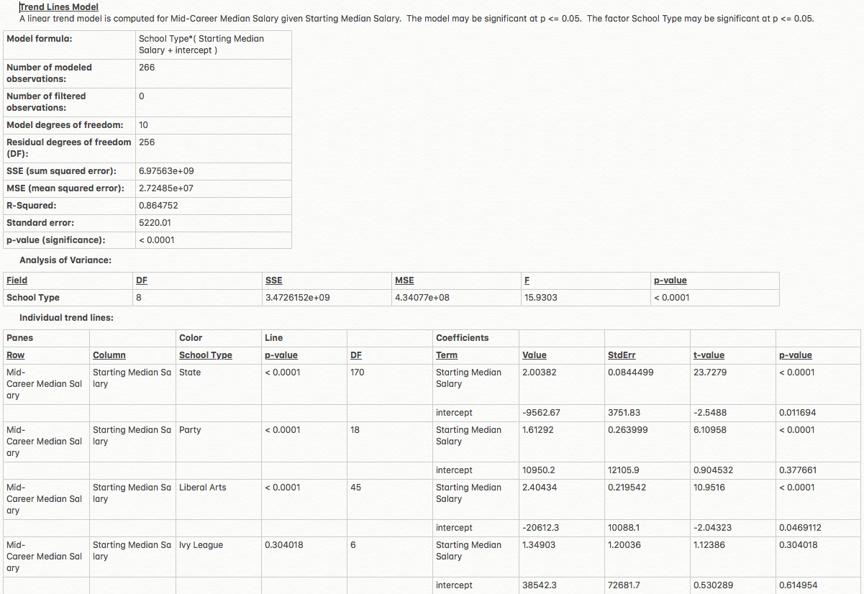



**APPENDICES**

**Appendix C – Output of Salaries by Region.**

ANOVA output of Starting Salaries:

 

 

ANOVA output of Starting Salaries:

 

 

Tableau public Links:

<https://public.tableau.com/shared/8YMDNXBD7?:display_count=yes>

<https://public.tableau.com/views/AnalysisofSalariesbyRegionandtypeofschool/Dashboard2?:embed=y&:display_count=yes&publish=yes>